Journal of Progressive Chemistry

Martin ruin^{a,}*, Peter Anderson^{b}, Meri antoaniª, Ferni Lakitaª
ªDepartment of Chemistry, Emperial University, P.O. Box 19395-3697 london, England.
^{b}Department of Engineering Science, University College of Engineering, University of Amesterdam, P.O. Box 11365-4563, Amesterdam, Netherland.

Vibrational Spectroscopy, Geometrical Parameters and DFT Calculation Of Co(III) Triflouruacetylacetonate

Article history:
Received: 31/Jan/2016
Received in revised form: 5/Apr/2016
Accepted: 20/Apr/2016

Abstract
In the present work, ……………………

Keywords: Micro- spherical, Co(AA)₃, Photocatalyst.

- Introduction
was characterized by X-ray diffraction (XRD), UV-Vis. spectrophotometer amethylene blue (M.B.) and methyl orange (M.O.) was examined.
- Experimental procedure
- Materials and method
Photocatalytic experiments
In this study the mixture of methylene blue (M.B.) and methyl ……………
- Results and discussion
The reusability of the SnO2/Zn2SnO4 sample was investigated through 4 cycles of experiments for decolorization of a mixture of M.B. and M.O. dyes solution. The reusability of the sample after four consecutive uses was obtained to be 98, 95, 90, 90 % (Fig. 5).
5. Conclusion
In conclusion, a simple refluxing method is presented for synthesis of the new …………
Acknowledgments
We are grateful to Emperial University for its financial support.
References
[1] M. Ahmad, B. Manuchehr, M. Parasto, R. Reza, J. Of Applied Chemistry, 14 (1394) 92, in Persian. (This style is for Persian Journal Papers)
[2] R. A. Vargas, A. Garciá and M. A. Vargas, Electrochim. Acta 43 (1988) 1271. (This style is for Journal Papers)
[3] J. Newman, Electrochemical Systems, 2nd ed., Prentice–Hall, Englewood Cliffs, NJ, (1991) pp. 256. (This format is for Books)
[4] M. Ocana, R. Rodriguez-Clemente and C. J. Serna, Adv. Mater.7 (2002) 212

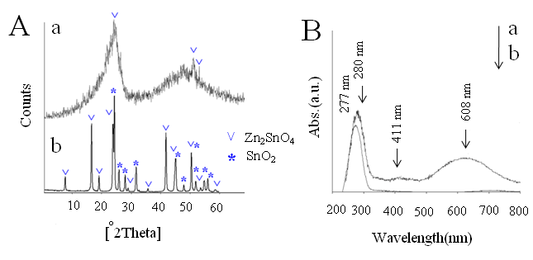
Fig. 1. The XRD patterns (A) and UV-Vis. absorption spectra (B) of the (a) amorphous and (b) SnO₂/Zn₂SnO₄ samples.

Fig. 2. The SEM images of (a, b) amorphous and (c, d) SnO₂/Zn₂SnO₄ samples

Fig. 3. UV-Vis. spectra changes of a two dye mixture- methylene blue (M.B.) and methyl orange (M.O.) solution in the presence of (a) amorphous and (b) SnO₂/Zn₂SnO₄ samples in dark and under UV-Vis. irradiation conditions

